# Lab 8.2 Use a Test Score array

In this exercise, you’ll work with an array and you’ll add nodes to the DOM to display the Results and the Scores.

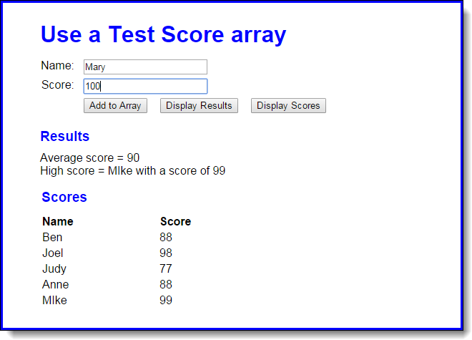

1. Open the HTML and JavaScript files in this folder.

Then, run the application to see the user interface shown above, although that interface won’t do anything until you develop the JavaScript for it.

1. As the start of the JavaScript file, you’ll see the declarations for two arrays: one for names and one for scores, and each array contains four elements. You’ll also see the code for the $ function as well as an onload event handler that attaches three functions name addScore, displayResults, and displayScores to the click events of the buttons.
2. Write the displayResults function. It should derive the average score and the highest score from the arrays and then display the results in the div element with “results” as its id, as shown above. To display the results, you need to add nodes to the DOM with the heading as an h2 element and the average and highest scores as <p> elements. The easiest way to do that is to use the innerHTML property.
3. Write the displayScores function. It should get the names and scores from the arrays and display them as rows in the HTML table element with “scores_table” as its id, as shown above.
4. Write the addScore function. It should add a name and score to the two arrays. To test whether this works, you can click the Display Scores button and see if the new name and score has been added to the table.
5. If you haven’t already done it, add data validation to addScore function. The Name entry must not be empty and the Score entry must be a positive number from 0 through 100. If either entry is invalid, use the alert method to display this error message: “You must enter a name and a valid score”.
6. Make sure that your application moves the cursor to the Name field when the application starts and after a name and score have been added to the array.